**Design of a Novel Antibiotic-Doped Thin Film for Intraocular Lens Implants**

BME 599 Project Paper

Chris Joren, Aditya Hegde, Jeff Womack, Michael Pennington

04/29/2017

**Abstract**

Endophthalmitis is a serious infection inside the eye that can occur after cataract surgery when an intraocular lens is implanted. This is especially troubling in developing nations where sanitation and patient after-care can be severely lacking. Several species of Staphylococcus bacteria can enter the eye during surgery and can adhere to the surface of the implant to create a biofilm that is usually impossible to treat with antibiotics. This study aimed to design an antibiotic doped thin-film that could deposited on an intraocular lens to be used in place of standard implants. This implant would administer a burst dose of ciproflaxin, a broad-spectrum antibiotic, to kill any bacteria on the implant; and continue to release antibiotics directly into the eye for up to a week after implantation. The method used to create this implant was a polyurethane intraocular implant deposited with an antibiotic doped polyethylene glycol thin film using Radio Frequency glow discharge plasma deposition. This deposition method helps to control the release of the drug versus other deposition techniques.

**Introduction**

Cataracts are the world’s leading cause of blindness, with over 62% of complete blindness cases attributed to cataracts (Pendke *et al.,* 2016). While cataract surgery is a common outpatient procedure in many developed countries, developing countries can reach crisis levels of blindness due to undertrained doctors, overwhelming population-to-surgeon ratios, and patients ignoring the problem until it resolves to complete blindness (Kim *et al.,* 2017). Many of these developing countries rely on volunteer non-government organizations (NGOs) to provide relief in times of crises, with organizations like the World Health Organization (WHO) and Doctors-Without-Borders creating temporary “eye camps” to treat up to thousands of patients a day (Pendke *et al.,* 2016). While these eye camps can help to temporarily lower the incidence of cataract-caused blindness, they are often underfunded and over worked – leading to a lower consultation period with the patient and relaxed hygiene standards.

The purpose of this study is to develop a novel intra-ocular implant coated with an antibiotic-doped thin-film to reduce the risk of infection following cataract surgery in developing nations. This implant will replace the standard intra-ocular implant that is used to replace the cataract that has formed in the eye lens, and to aid doctors performing surgery in remote areas where access to advanced medical care after surgery is insufficient. While a successful implant might generate considerable income, this team has decided to patent the invention only to protect it from theft, but to offer the methods and production means to any manufacturer that agrees to sell the implants at-cost to non-profit organizations operating in developing countries, or to local surgeons performing operations in these countries. We believe that profit will still exist to make production desirable to manufacturers marketing in developed countries, and that this device could save the vision of thousands of people every year.

**Background**

While cataract surgery is completely successful in restoring vision in well over 99% of cases (Jabbarvand *et al.,* 2016), post-operative infection is still a major cause of concern. In developed countries, the incidence rate of post-operative infection for cataracts, known as endophthalmitis, is as low as 0.04%, developing countries can see incidence rates of up to 0.41%. These numbers may seem small, and in relation to infection rates of other surgeries they are, but the complications of endophthalmitis result in complete and irreversible blindness in up to 33%, while 50% never gain vision past being able to count fingers (a common visual acuity test) (Jabbarvand *et al.,* 2016.) One study of a WHO eye camp in India reported 3 cases out of 458 surgeries resulting in endophthalmitis (Fig. 1), with the outcome of all 3 cases being reported as “poor” (Fig. 2), meaning a visual acuity test result of finger counting or worse (Penke *et al.,* 2016). 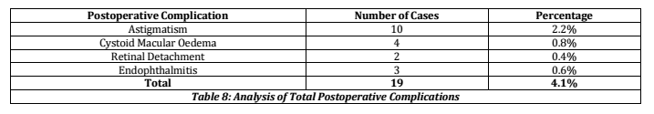

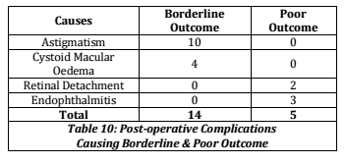

China is considered a developed country, but still retains a high level of rural populations with limited access to healthcare. A study performed in 2016 on small and medium-sized ophthalmology clinics in china reported that 52 cases of endophthalmitis occurred in 46000 operations, a 0.11% rate (Zhu *et al.,* 2017). While this rate is high for a developed country, the results also indicate that over 70% of patients returned to the surgeon before their vision reached 20/70, and over 50% of the patients regained or maintained vision loss at 20/70 or less. The severity of this vision loss, while devastating, is far lower than the outcomes in developing nations which can report complete vision loss of up to 75% of infected patients. The reason for the decreased numbers of severe vision loss is due to the ability of even rural patients to be treated at a modern hospital, even if it is some distance away, while in developing countries a better hospital might not be an option. Another reason is that the patients were able to return to their surgeon, an option not available to patients who received treatment at a temporary eye camp.

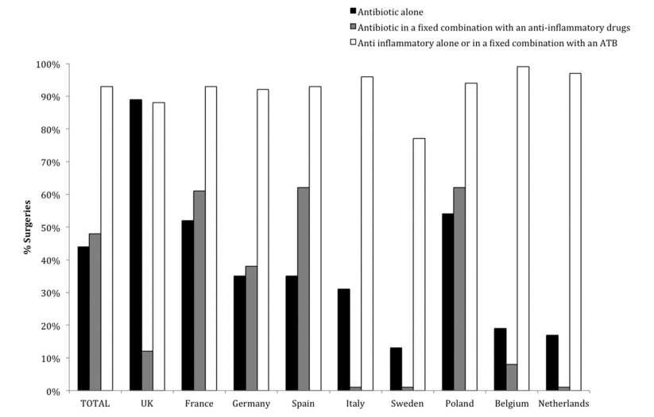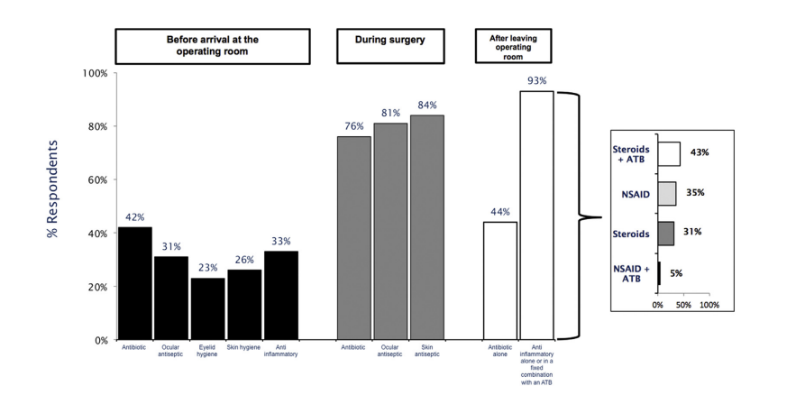Two of the major reasons for endophthalmitis occurring at such a higher rate in developing countries are improper sanitation procedures, and inconsistent post-operative care. The standard operating procedure for cataract surgery sanitation is summarized in figure 3, but consists of practices before, during, and after surgery. A study of cataract surgeries conducted in Europe summarized helped to establish a standard of care, and to determine the best practice methods for performing surgery (Behndig *et al.,* 2016). Prophylactic antibiotics and antiseptics were often used before surgery, with the addition of scrubbing the eye and surround areas and trimming the eyelashes. Antibiotics and antiseptics were also used during the surgeries in most countries, as either topical drop or intravenously administered. After-care is typically anti-inflammatory and antibiotic eye drops (Fig. 4).

Hand hygeine is a major concern for infection in developing countries, with many doctors performing surgery without meeting the standards approved by WHO. When discussing developing nations it is impossible to ignore many countries in Africa. One study performed in Uganda in two hospitals specifically addressed hand-hygeine in opthamalgic outpatient surgeries and found that not only were WHO standard not met, but the facilites themselves were severely deficient in sanitation opportunities (Mearkle *et al.,* 2016). These findings suggest that opportunities for hand hygeine were missed in all aspects of surgery and patient consultation (Fig. 5), and that alcohol hand sanitizers were used far more often than soap when sanitation was conducted (Fig. 6). These practices seem outlandish, but a similar WHO study in high-income countries found that only 40% of facilities were compliant in hand-sanitation guidelines (Mearkle *et al.,* 2016). These abyssmal rates of proper sanitation are a major concern for opthamalogic surgery infection rates, especially when these surgeries are conducted with minimal rest time between patients as in eye camps.

Besides hand hygeine, another huge factor at play in infection rates is patient compliance with post-operative care. Eye drops; whether steroid, antibiotic, or anti-inflammitory are usually dispensed to the patient after surgery with specific instructions. Many of these drops must be administered up to three times a day, with a significant wait time between the different drops. A compliance study conducted in 2014 showd that the average cataract surgery patient only used half of the prescribed drops (Tyson *et al.,* 2016), and that 93% of patients incorrectly administered the drops by either contamination of the dropper, missing the eye, or administering an incorrect number of drops. These results were measured with video analysis that also showed more than half of the patients administered the separate drugs without waiting the mandatory 5 minutes for the first drug to be adsorbed. This study suggests that eye drops for post-operative antibiotic administration are ineffective, especially in communities that are prone to distrust medication or to halt use since their vision seems back to normal.

**Approach**

Sveeral different approaches have been tried to solve the problem of endophthalmitis following cataract surgery, none have been completely successful. Part of this is due to insufficient material on how to best kill the bacteria, whether before implantation or after, but the biggest hurdle is how to deliver the drug into the eye, a particularly difficult procedure. Eye drops are designed to be adsorbed, however, much of the drug can’t penetrate deep into the fluid-filled outer layers of the eye, letting some bacteria survive. When the bacteria on an implant survive prophylactic antibiotics and sterilization procedure, they begin to adhere to the surface of the implant, creating a biofilm. One colonization has occurred, this biofilm begins to secrete chemicals to bind the cells firmly to the surface. As the biofilm grows it will recruit other bacterial cells as well as debris into the matrix, forming a film that is extremely hard to eradicate (Kwok *et al.,* 1999). Not only is this biofilm hard to destroy due to its adhesion, but the cells also undergo a phenotypic change, making them even more resistant to antibiotics (Giglio *et al.,* 2011). Once an infection of this magnitude occurs, the only treatment method is to remove the device and replace it, however, this surgery is dangerous due to the biofilm thickness and can often lead to eye damage. If left untreated, this infection will almost certainly lead to blindness and even death (Sadaka *et al.,* 2017).

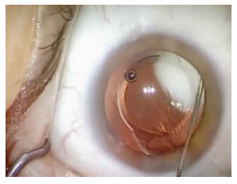

One approach to stopping this biofilm buildup is with an intracameral (directly into the fluid chamber of the eye) injection of antibiotics (Fig. 6) (Tyson *et al.,* 2016). A retrospective study showed that in 16000 cases, an intracameral injection of antibiotics and corticosteroids reduced the prevalence of endophthalmitis 37-fold (Tyson *et al.,* 2016). The results of these injections are very positive, and the antibiotics can dwell in the eye for 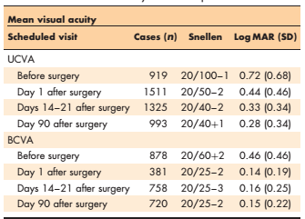up to 3 months post-injection. Fig. 7 shows the visual acuity results from several hundred patients with 96% receiving only one dose and the remainder receiving two doses after surgery. The acronyms UCVA and BCVA refer to uncorrected visual acuity and best corrected visual acuity. While this method of treatment is very effective, it is unfortunately not right for this study. A intracameral injection is an extremely delicate procedure, and one that can easily cause blindness if misadministered. The goal of this study is to find a simple solution to replace a surgery already in place, one that doesn’t require the retraining of many doctors and one that minimizes risk to the patient when doctors are extremely fatigued after long days working at eye camps.

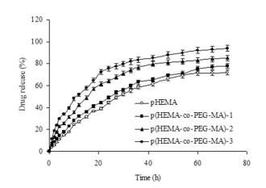One popular method for releasing antibiotics over time is using hydrogels. Hydrogels are unique in that their permeability, surface properties, and permselectivity mimic that of natural tissue (Bayramoglu *et al.,* 2008). Hydrogels containing polyethylene glycol (PEG) are especially interesting in that they have low protein adsorbtion and cell adhesion, making them great for discouriging bacterial biofilms. Drug delivery from hydrogels are highly dependant on their material properties and the drug used, but tend to release drugs quickly, which would aid in killing any bacteria present on the device during implantation (Fig. 7). Hydrogels studied on titanium hip implants doped with Ciproflaxin, a broad-spectrum antibiotic particularly useful against the two strains of Staphylococcus that cause endophthalmitis, showed a remarkable inhibition of bacterial growth in lab cultures (Giglio *et al.,* 2011) (Fig. 8).

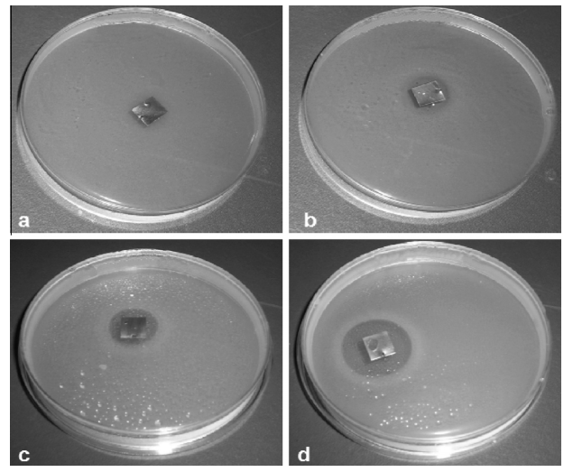

While hydrogels can be effectively used for many implants, they swell in aqueous solutions and would therefore increase the pressure in the eye, likely causing damage (Fig. 9).

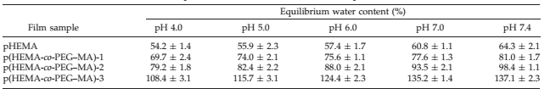

Another approach to ocular drug delivery is in erodible films. These films are made of polymers that are bio-compatible, non-reactive, and able to release drugs in a controlled manner. This is a far superior method of drug delivery to eye drops, since only 5% of the drop dose can penetrate the ocular barriers and prolonged drug treatment can’t be achieved (Boateng *et al.,* 2016). Erodible films can be tailored to erode at a specific rate, and able to release the doped drug at a commensurate rate. This is an ideal situation for treating endophthalmitis, as a high initial dose or a prolonged dose could both be studied 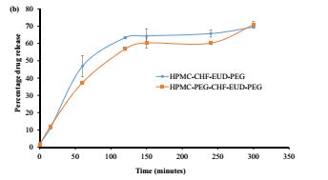to determine optimal dosing. The drug release is slower than that of hydrogels, but without the swelling associated with being places in the vitreous fluid of the eye (Fig. 10). While erodible films are ideal for drug delivery, their adhesion to substrates isn’t well studied, and they are optimally used as a contact lens for frontal eye injuries requiring antibiotics (Boateng *et al.,* 2016).

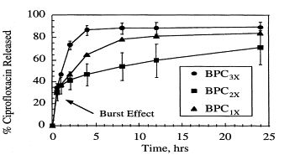Polyurethane is a very common polymer used in many applications. While typically associated with ridgid materials, polyurethane is a chemical that can be made flexible or ridgid depending on its composition andmanufacture. It is a biocompatible material and can be easily coated with a pore-forming film to allow for drug release (Kwok *et al.,* 1999). With PEG as a pore former, it has been shown that drug delivery of ciproflaxin can be released at a controlled rate depending on the PEG loading (Fig. 11). The net accumulation of bacteria in this study was significantly reduced with ciproflaxin loaded films (b) vs unloaded (a) in Fig. 12.

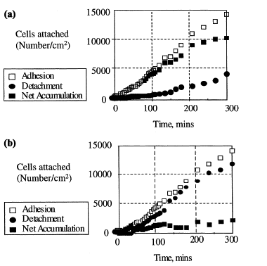

**Methods**

The design of this lens is based on the two studies by Kwok et al. in 1999. The polyurethane intraocular implant will be manufactured using the methods described in (Bozukova *et al.,* 2014) by an outside company to be decided if this project is continued.

The films will be created using 0.4g of ciproflaxin, 0.4g of polyethylene glycol, and 2.26g of BIOSPAN. The PEG and ciproflaxin are then suspended in the BIOSPAN solution. Radio Frequency glow discharge plasma deposition (RF-GDPD) will be conducted to coat the implant by suspending it between two electrodes that are 5 inches apart. The specimens will be first in an argon plasma before butyl methacrylate plasma deposition of the film to eliminate the burst effect of the drug delivery and to deliver a controlled release of the ciproflaxin.

These lenses will first be submerged in simulated body fluid for testing, with additional sampling being done in saline and water to determine drug release times. The ciproflaxin will be measured in the solute by sampling a 4ml amount every hour until the ciproflaxin is all contained in the solute.

The plasma reactor used for this experiment will be outsourced or built at the university, depending on funding availability.

Results for a similar test on a flat polyurethane disk are shown below in Figs. 12-15 (Kwok *et al.,* 1999)

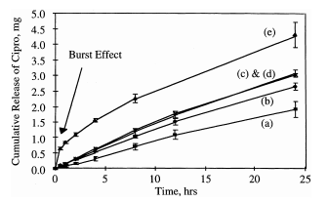

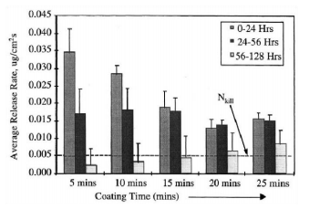

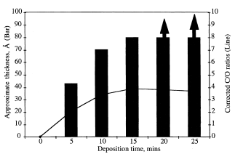

**Funding**

The funding for this project is currently $0. With one member of the team graduating, and the remaining members of this project on a non-thesis master’s track, it is uncertain if funding will be attempted.

**Patent Search**

The criteria used for these searches were first to see what has been done in the field of intraocular lenses. These are what actually go into a patient’s eye to replace the natural lens that would be removed due to cataract surgery. The second search was conducted to see if any lenses have patents for antimicrobial thin films or anything to combat endophthalmitis. The goal is to use information from these two patent searches to find a suitable innovative method or design for our thin film interactions.

First to be discussed is the results for patents concerning advances in intraocular lenses. There is a patent (US 8778022 B2) for an electro-active intraocular lens. This features an electro-active element that can be folded for insertion into the eye where it will unfold on its own similar to how some current lenses work. This design also features controllable zones or pixels that are remote controlled by a controller eliminating the need for touching. Piezo-electric elements are attached to a special tab that allows the device to connect to the ciliary body. This ciliary body is essentially a muscle that controls the ability of the person to focus their vision by causing the lens to bend more or flex more in order to bring an object into focus and as a person ages this ciliary body will begin to weaken causing an inability to focus. The piezo-electric element registers this contraction or extension and produces an electrical voltage that can be interpreted by the controller to cause each of the zones to focus independently to produce a focused image. One part of this patent that was missing was the biocompatibility component or how it reduces the chance of post operation infections. A second patent for “Double accommodating intraocular accordion lens” (USPTO# 20170071728) shows another way that a lens can be created in an innovative way.

Second is to check for any patents regarding intraocular lenses with antimicrobial properties. There are many out there making this section very important so as to not replicate something already done. Patent US 5843186 A “Intraocular lens with antimicrobial activity” uses antimicrobial iontophoretic materials. This is comprised of a polymer matrix with two materials with galvanic electric potentials dispersed throughout it and the matrix has an electrical resistivity allowing the current between the two materials to be controlled when the intraocular lens is in contact with saline fluid in the eye. In the patent the claim is that the polymer matrix is comprised of polyethylene, polypropylene, PMMA, and/or silicone and the two materials are silver and platinum. Patent WO 2014096852 A1 “Antimicrobial ophthalmic contact lenses” reference using a hydrogel with epsilon polylysine non-covalently attached to the hydrogel. Patent EP 1050314 A1 “Antimicrobial contact lens” claims an ocular lens with a polymeric material comprised of zeolite in an antimicrobial-effective amount and metallic cations. This isn’t a patent but there is a review article on drug-eluting intraocular lenses that can prevent infections by several different methods: “combination of the IOL with an insert in a single device, soaking in drug solutions, impregnation using supercritical fluids, coating with drug/polymer layers, and covalent grafting of the drug” (Gonzalez-Chomon).

The third search is for patents involving thin films and intraocular lenses. Patent US 4909626 A “Electrically-controllable thin film Fresnel zone device” uses an electronically controllable optical component comprised of two planar surfaces with a thin film birefringent material confined between them where an electrical field can be applied. This produces a wavefront that can be divided into Fresnel zones. There is also an article available that claims an implantable medical device with a thin film of platinum that acts as a body enzyme that catalyzes the reduction of peroxide compounds and scavenge toxic free radicals which prevents cellular dysfunction resulting from an oxidative attack (Babizhayev).

All of this can also contribute to an alleged patent by google for a smart lens that is very high tech. The problem would be to ensure all of the electronics are insulated so as to not damage the eye or require any follow-up surgery or lead to a complication requiring more money and patient discomfort to correct.

**Discussion**

Endophthalmitis is a rare condition, but one that is easily treatable with proper preventative measures and access to medical facilities. Cataracts remain a huge problem in the world, and with an ever-increasing human lifespan the problem will only get worse. Many volunteer and non-profit organizations work tirelessly to combat this problem, but remain challenged with improper facilities, untrained local doctors, budget restraints, and patients who can’t understand the need for after-care. The intraocular lens created with this technique could help to solve this problem by eliminating bacteria already on the lens during implantation, and continuing to administer antibiotics for up to a week after implantation. This would eliminate the need for antibiotic eye drops, and hopefully reduce the number of patients who experience blindness again after only a short period of regaining sight after cataract surgery.

**Future Directions**

The biggest hurdle towards preparing future directions and timelines is the dynamic nature of our group. With one member graduating, and the others invested in other research, it is unlikely that this project will be completed. Funding is a major difficulty for non-thesis master’s students, and without the support of a PhD mentor, it is unlikely that a grant would be completed adequately or approved by a funding body. The current state of federal funding for science has been drastically reduced, and grants from any federal institutions will only become harder to obtain during the tenure of the current president.

While the research done by Kwok *et al.* is fairly comprehensive, their testing methods involved a flat disk of polyurethane and not a concave lens structure. This geometry difference may play a large role in drug dispersion, and must be thoroughly researched before animal and human testing. Only one deposition method was tried, and while successful, several more methods could be used to determine the most cost effective deposition method to achieve acceptable results.

A final future direction would be to collaborate with a material science team developing a flexible polyurethane. All studies done for intraocular lenses using polyurethane had the sample created in-house. A collaboration would allow us to purchase samples from them for testing versus attempting to buy them on the open market, where none are currently available. This study would be an ideal candidate for a funded master’s thesis, and the group agrees that any future student is welcome to the material provided in this report.

**Works Cited**

Yannuzzi, Yicolas A, Si, Nancy, Relhan, Nidhi, Kuriyan, Ajay E, Albini, Thomas A, 2016. Endophthalmitis After Clear Corneal Cataract Surgery: Outcomes Over Two Decades. American Journal of Opthamology. doi:10.1016/j.ago.2016.11.006

Mearkle, R., Houghton, R., Bwonya, D., Lindfield, R., 2016. Barriers to hand hygiene in ophthalmic outpatients in Uganda: a mixed methods approach. Journal of Ophthalmic Inflammation and Infection 6. doi:10.1186/s12348-016-0077-0

Behndig, A., Cochener, B., Guell, J., Kodjikian, L., Mencucci, R., Nuijits, R., 2016. Surgical, antiseptic, and antibiotic practice in cataract surgery: Results from the European Observatory in 2013. Journal of Cataract Refractive Surgery 41. doi:10.1016/j.jcrs.2015.06.031

Zhu, T., Chen, X., Chen, P., Wu, J., Yao, K., 2017. The occurrence rate of acute-onset postoperative endophthalmitis after cataract surgery in Chinese small- and medium-scale departments of ophthalmology. Scientific Reports 7. doi:10.1038/srep40776

Jabbarvand, M., Hashemian, H., Khodaparast, M., 2016. Endophthalmitis Occuring After Cataract Surgery. Journal of Ophthalmology 123. doi:10.1016/j.ophtha.2015.08.023

Pendke, S.S., Bhalgat, S.S., 2016. critical analysis of visual outcome in clear corneal manual small incision cataract surgery at eye camps. Jounrnal of Evolution of Medical and Dental Sciences. doi:10.14260/jemds/2016/592

Sadaka, A., Durand, M.L., Sisk, R., Gilmore, M.S., 2015. Staphylococcus aureus and its Bearing on Ophthalmic Disease. Ocular Immunology and Inflammation 25, 111–121. doi:10.3109/09273948.2015.1075559

Tyson, S.L., Bailey, R., Roman, J.S., Zhan, T., Hark, L.A., Haller, J.A., 2017. Clinical outcomes after injection of a compounded pharmaceutical for prophylaxis after cataract surgery. Current Opinion in Ophthalmology 28, 73–80. doi:10.1097/icu.0000000000000329

Boateng, J., Popescu, A., 2016. Composite bi-layered erodible films for potential ocular drug delivery. Colloids and Surfaces B: Biointerfaces 145, 353–361. doi:10.1016/j.colsurfb.2016.05.014

Sun, S., Li, J., Li, X., Lan, B., Zhou, S., Meng, Y., Cheng, L., 2016. Episcleral drug film for better-targeted ocular drug delivery and controlled release using multilayered poly-ε-caprolactone (PCL). Acta Biomaterialia 37, 143–154. doi:10.1016/j.actbio.2016.04.014

Bayramoğlu, G.C.B.C., Batislam, E., Arica, M.Y., 2009. Preparation and drug-release behavior of minocycline-loaded poly[hydroxyethyl methacrylate-co-poly(ethylene glycol)-methacrylate] films. Journal of Applied Polymer Science 112, 1012–1020. doi:10.1002/app.29450

Giglio, E.D., Cometa, S., Ricci, M., Cafagna, D., Savino, A., Sabbatini, L., Orciani, M., Ceci, E., Novello, L., Tantillo, G., Mattioli-Belmonte, M., 2011. Ciprofloxacin-modified electrosynthesized hydrogel coatings to prevent titanium-implant-associated infections. Acta Biomaterialia 7, 882–891. doi:10.1016/j.actbio.2010.07.030

Kwok, C.S., Wan, C., Hendricks, S., Bryers, J.D., Horbett, T.A., Ratner, B.D., 1999. Design of infection-resistant antibiotic-releasing polymers: I. Fabrication and formulation. Journal of Controlled Release 62, 289–299. doi:10.1016/s0168-3659(99)00106-6

Kwok, C.S., Horbett, T.A., Ratner, B.D., 1999. Design of infection-resistant antibiotic-releasing polymers: II. Journal of Controlled Release 62, 301–311. doi:10.1016/s0168-3659(99)00105-4